Artículos científicos
Factors that affect oral production of English in language students
Factores que afectan la producción oral del inglés en estudiantes de idiomas
Fatores que afetam a produção oral de inglês em alunos de idiomas
Pedro Antonio Morales Uriostegui
Universidad Juárez Autónoma de Tabasco, México
pamu881222@gmail.com
https://orcid.org/0000-0003-2341-5447

Eleazar Morales Vázquez
Universidad Juárez Autónoma de Tabasco, México
eleazarmove@gmail.com
https://orcid.org/0000-0003-1596-5043

Abstract
Oral production of the English language is one of the skills that causes the most complications for language learners. Some authors have pointed out that the origins of these complications can be varied, from aspects related to the teaching-learning environment to personal factors in students such as emotions. For this reason, this article presents an investigation that was carried out at the Universidad Juárez Autónoma de Tabasco with the participation of students of the Bachelor of Languages, with the aim of identifying the factors that affect their oral production in English and thereby being able to establish teaching methods that meet the needs of learners. The research was of mixed approach and descriptive type. A structured questionnaire was used in which quantitative and qualitative data could be collected. The results showed that the students have difficulties due to the little practice of English during their classes, since they do not feel sufficiently prepared to express themselves orally in English when they are evaluated or when they must speak with other people, since they do not carry out enough activities to be able to improve. their oral production. This circumstance also affects the learners emotionally, as they are afraid to participate and when they speak English they often feel very nervous, embarrassed, anxious and even unable to communicate.
Keywords: English, language teaching, oral expression, affective factors.
Resumen
La producción oral del idioma inglés es una de las habilidades que ocasiona más complicaciones para los aprendices de lenguas. Algunos autores han señalado que los orígenes de estas complicaciones pueden ser variados, desde aspectos relacionados con el ambiente de enseñanza-aprendizaje hasta factores personales en los estudiantes como las emociones. Por ello, en este artículo se presenta una investigación que se realizó en la Universidad Juárez Autónoma de Tabasco con la participación de estudiantes de la Licenciatura en Idiomas, con el objetivo de identificar los factores que afectan su producción oral en inglés y con ello poder establecer estrategias de enseñanza que permitan atender las necesidades de los aprendices. La investigación fue de enfoque mixto y tipo descriptivo. Se utilizó un cuestionario estructurado en el que se pudieron recolectar datos cuantitativos y cualitativos. Los resultados mostraron que los estudiantes tienen dificultades debido a la poca práctica del inglés durante sus clases, ya que no se sienten suficientemente preparados para expresarse oralmente en inglés cuando son evaluados o cuando deben hablar con otras personas, pues no realizan actividades suficientes para poder mejorar su producción oral. Esta circunstancia también afecta emocionalmente a los aprendices, pues sienten temor de participar y cuando hablan inglés suelen sentirse muy nerviosos, avergonzados, ansiosos e incluso incapaces de comunicarse.
Palabras clave: inglés, enseñanza de idiomas, expresión oral, factores afectivos.

Resumo
A produção oral da língua inglesa é uma das habilidades que mais complicações traz para os aprendizes de línguas. Alguns autores apontam que as origens dessas complicações podem ser variadas, desde aspectos relacionados ao ambiente de ensino-aprendizagem até fatores pessoais dos alunos, como as emoções. Por isso, este artigo apresenta uma investigação realizada na Universidad Juárez Autónoma de Tabasco com a participação de alunos do Bacharelado em Letras, com o objetivo de identificar os fatores que afetam sua produção oral em inglês e com isso poder estabelecer estratégias de ensino que atendam às necessidades dos alunos. A pesquisa foi de abordagem mista e do tipo descritiva. Utilizou-se um questionário estruturado no qual puderam ser coletados dados quantitativos e qualitativos. Os resultados mostraram que os alunos têm dificuldades devido à pouca prática do inglês durante as aulas, pois não se sentem suficientemente preparados para se expressar oralmente em inglês quando são avaliados ou quando têm que falar com outras pessoas, pois não realizar atividades suficientes para poder melhorar sua produção oral. Essa circunstância também afeta emocionalmente os aprendizes, pois eles têm medo de participar e quando falam inglês muitas vezes se sentem muito nervosos, envergonhados, ansiosos e até incapazes de se comunicar.
Palavras-chave: inglês, ensino de línguas, expressão oral, fatores afetivos.
Fecha Recepción: Abril 2021 Fecha Aceptación: Enero 2022

Introduction
According to Olivares (2017), the communicative ability that is required in the contemporary world must necessarily include mastery of the mother tongue, but also of English since it is the most used language for education, business, and even cultural exchanges. Therefore, oral expression is of the utmost importance for social interaction.
However, problems sometimes arise during the development of the oral production of language learners because the methodologies are not always adequate and limit learning. Thus, an ideal teaching should include entertaining methods and strategies for students that address everyday topics that can be acquired naturally (Figueroa & Intriago, 2022).
For this reason, this article presents an investigation that was carried out at the Universidad Juárez Autónoma de Tabasco with the aim of identifying the factors that affect the oral production of the students of the Bachelor of Languages, because through the literature review on the subject and thanks to empirical knowledge through observation in English classes, it has been possible to notice that for students this ability is usually difficult and is not always developed adequately, to such an extent that it does not correspond with the levels of the language they are studying, which can become a state of fossilization that can completely impair their performance and communication in this language. In this way, identifying the factors with the greatest incidence in the oral production of the apprentices will allow establishing teaching strategies according to the needs of the students.
Firstly, some findings found on this subject are briefly exposed. That is, the difficulties identified in various studies during the oral production of students are shown. Subsequently, the method that was implemented to carry out this research is described. Then the results are presented, a brief discussion about them, the conclusion of this article and finally some future lines of research are suggested to continue exploring this problem.

Difficulties in the oral production of English
Studies on learning the English language have shown different types of difficulties. These have been related to the abilities that make up the linguistic competence of a second language (L2). One of the abilities that represents more difficulty for students is oral production. Here are some arguments in this regard.
In relation to Navarro & Zarate (2016), students often have development problems during oral production even at an elementary educational level. Thus, these authors suggest that difficulties in oral abilities are linked to the learning activities that students develop in class. This argument places a great responsibility on the teaching process, which makes the English teacher an essential guide for this ability to develop.
In line with Figueroa & Intriago (2022), for students to obtain adequate oral production, they need to develop speaking practice both outside and inside the classroom. Consequently, the activities in the English class must be dynamic to motivate students to continue practicing the L2. In this way, both Navarro & Zarate (2016) and Figueroa & Intriago (2022) emphasize that what happens in the classroom conditions the development of students' oral production.
Otherwise, considering that oral expression is made up of articulation, voice, and fluency, it implies an interaction between people to achieve a specific use of language as a communicative process. For this reason, it is of vital importance that concrete experiences that promote social interaction take place during teaching (Olivares, 2017). Hence, these experiences that promote interaction between students should be included in as many activities as possible.
Moreover, it is difficult for English teachers to cover all the needs of the students and cover each of the abilities with the few hours of class per week since oral production is usually left aside to give priority to comprehension, reading, writing, and even listening (Gonzáles & Caldera, 2018).
In addition, it has been shown that students of English who have difficulties in oral production often have problems with motivation during their language learning. Therefore, the importance of teaching strategies adapted to the types of students to improve the oral production of students is highlighted. Likewise, these strategies must include stress-free activities that provide security in learners, with clear and precise instructions through the help of varied didactic material (Sagástegui, Vilca & Gonzáles, 2017).
This underlines the relevance of emotional aspects during the learning process. Hence, it can be considered that factors of this nature can also influence oral production of students.
One of the main studies on the processes of language acquisition and learning is the one carried out by Stephen Krashen, since in his theory he contemplates five main hypotheses to understand the brain process that occurs in a language learner. Thus, according to Krashen (1982), these are the hypotheses:
- The acquisition-learning hypothesis, in which it is argued that there are two different processes when appropriating an L2; the acquisition process, which occurs subconsciously in an environment where the person is exposed to the language and learning, which is a conscious and formalized process.
- The monitor hypothesis, in which it is argued that learners assimilate grammatical rules by monitoring the linguistic structures they produce.
- The natural order hypothesis, in which it is assumed that there is an innate order in which the brain acquires the linguistic structures of a language.
- The comprehensible input hypothesis, which is based on the fact that learner acquires the language and learns the grammatical rules when he is exposed to a large amount of linguistic content that he can understand plus a certain amount of content of a more advanced level.
- The affective filter hypothesis, which emphasizes that the brain of a language learner can activate or deactivate an abstract filter that can retain part of the knowledge depending on motivation, anxiety, and self-concept.
In this sense, one of the aspects that stands out most in Krashen's studies is the importance of affective factors during language learning since these can improve or limit the acquisition of knowledge. Therefore, it can be considered that this affectation can also occur during the students' oral production.
In addition, according to the study by Méndez (2016), the causes that most influence the emotions of language students come from the learning environment: the teacher (teaching, feedback) and classmates (reactions to errors). Thus, students often feel insecure, fearful, anxious, unmotivated and without the desire to participate orally in class. Similarly, if students are afraid of the opinions of their classmates and the teacher, this could alter the concept they have of themselves regarding their ability to communicate and they could feel inefficient in oral production.
Furthermore, Del Castillo (2010) points out that English students of the first levels are usually more motivated to acquire the language, since they are attracted by culture, music, customs, among other aspects. Therefore, when advancing in the study of the language, some students become demotivated and even abandon the learning process. In this way, this may suggest that advanced level learners do not have the same motivation that they had when they started learning the language, which may cause them to have less desire to speak and practice the language.
It has also been found that oral expression is the most difficult to manage affectively for language learners, since when speaking students feel anxiety, fear of making mistakes and difficulty finding the right vocabulary to express themselves in public. All this causes fear of the reactions of classmates and teacher (Kalan, 2007).

Method
This research was carried out from the mixed approach due to the characteristics of the topic analyzed, since according to Cortés and Iglesias (2004) it involves the use of instruments with a combination of quantitative and qualitative approaches to obtain opinions from the participants and data that can be measured numerically. In addition, the type of descriptive study was used, since this allows a detailed analysis of different characteristics, properties and important features within the phenomenon being studied, for which questionnaires are normally used and starting from observation to be able to analyze a problem.
The population consisted of students of the Bachelor of Languages degree at the Universidad Juárez Autónoma de Tabasco. To be able to study the problem in an environment in which oral production was required, a sample of 30 students between the ages of 22 and 25 years who were taking the Advanced English course was selected.
This sample was determined by establishing an equivalent percentage of students of Advanced English in two different groups in order to have participants with different academic circumstances.
On the other hand, to cover the mixed approach, an instrument whose design allowed collecting quantitative and qualitative data was made. This consisted of a questionnaire that was divided into four sections. The first, second and third sections were structured based on tag questions with the aim of obtaining precise quantifiable information, while the fourth section was used to acquire more details about the problem through open questions for the students. In turn, these sections were structured based on main categories and subcategories, which are summarized in Table 1 below:

Table 1. Categorization guide for instrument
Categorization guide for instrument
Section | Category | Subcategory
First | Academic considerations regarding oral production in English | Coincidence between the real level of the English language with the current level in the career
 |  | Perception about difficulty of oral ability
 |  | Preference to be evaluated
 |  | Perception about the functionality of the real level of English to obtain an IELTS certification
Second | Circumstances in class regarding the oral use of English | Permanent use of English when speaking in class
 |  | Motivation to speak English in class
 |  | Use of test to assess oral ability
 |  | Carrying out various activities such as the use of audiovisual resources, linguistic games, or conversations in class
Third | Affective perceptions about oral production in English | Incidence of nervousness when speaking English
 |  | Incidence of embarrassment when speaking English
 |  | Incidence of anxiety when speaking English
 |  | Affectation for feeling inefficient when speaking English
Fourth | Student opinions | Factors that mostly affect oral production according to students
 |  | Proposals to develop oral production according to students
Note: Own elaboration
Moreover, the questionnaire was made by using the categories as said before and questions about personal information were included to obtain control data. Thus, it was possible to apply the instrument with the support of English teachers. It was specifically explained each category to the students with the objective of elucidate any aspect that could create confusions and produce unfunctional answers. Likewise, it was explained that control data obtained would be confidential and only would be used with scientific purposes. This procedure was implemented with the voluntary participation of students, as well as their approval to use the given information.

Results
First section: Academic considerations regarding oral production in English
For the first category of this research, in which it was sought to know some considerations of the students about the ability of oral production in English, the results are presented below.
On the one hand, as can be seen in Figure 1, most of the students consider that the level they have of the English language does not correspond to the level they are studying in the career, which is advanced.

Figure 1. Real English level of students taking Advanced English
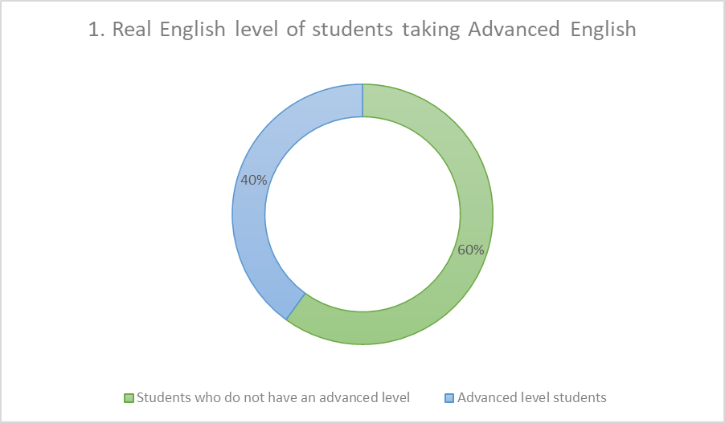
Note: Own elaboration
On the other hand, when questioning the students about the difficulty in oral ability in English language, the majority considered what is showed in Figure 2.

Figure 2. Perception about oral ability
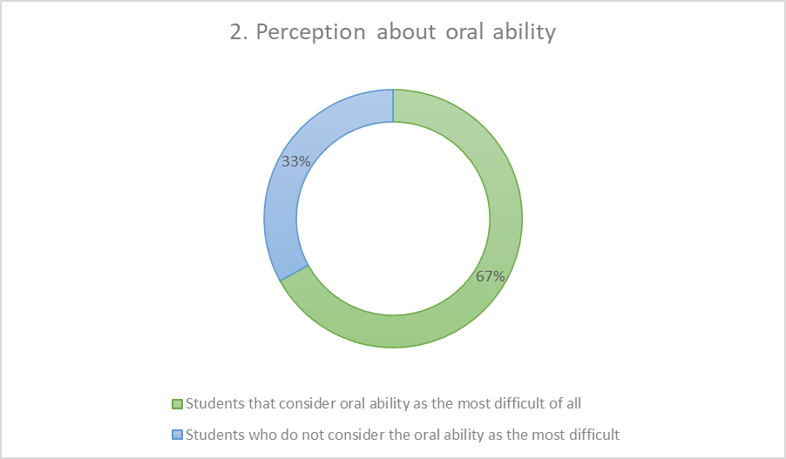
Note: Own elaboration.
In addition, this study sought to know how students prefer to be assessed. This information is shown in Figure 3.
Figure 3. Preference to be evaluated
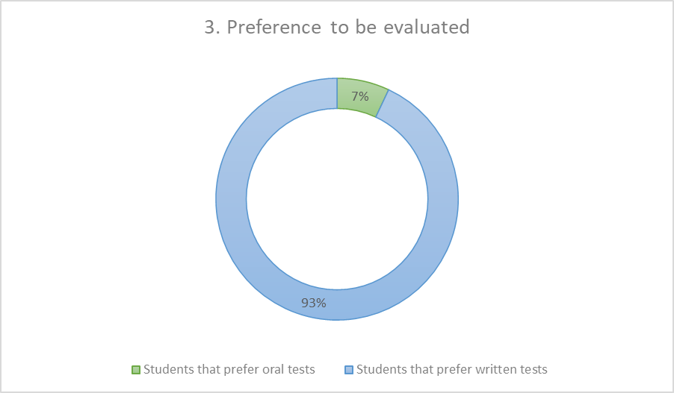
Note: Own elaboration.
The students were also questioned to find out if, according to their criteria, they considered that their actual level of English language was functional to obtain an IELTS certification.
The results are shown in Figure 4.
Figure 4. Perception about the functionality of the real level of English to obtain an IELTS certification
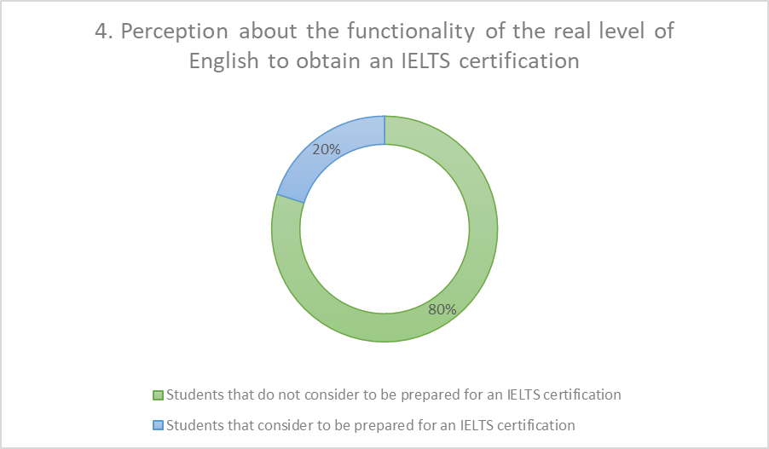
Note: Own elaboration.

Second section: Circumstances in class regarding the oral use of English
In this category, it was sought to know the circumstances of the students regarding the oral use of the English language during their classes in the career. In the first place, they were asked if they made permanent use of the English language when speaking in class. This information can be seen in Figure 5 below.
Figure 5. Permanent use of English when speaking in class
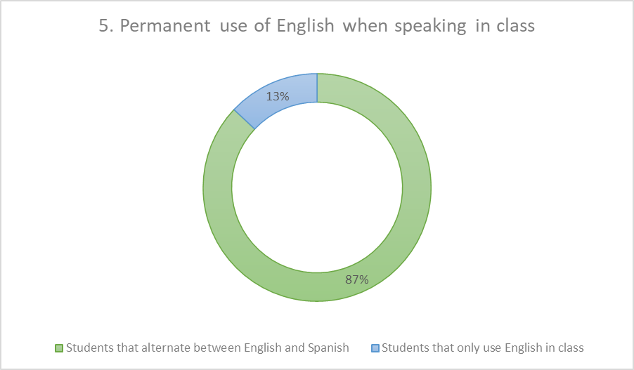
Note: Own elaboration.
In addition to the above, the participants were asked if they were constantly motivated to speak English in class. It is shown in Figure 6.
Figure 6. Motivation to speak English in class
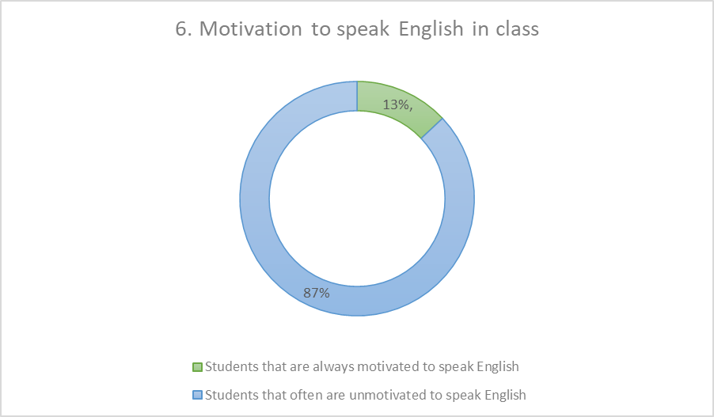
Note: Own elaboration.
On the other hand, it was sought to know if the students took exams to be evaluated in English speaking skills. This is depicted in Figure 7.
Figure 7. Use of test to assess oral ability
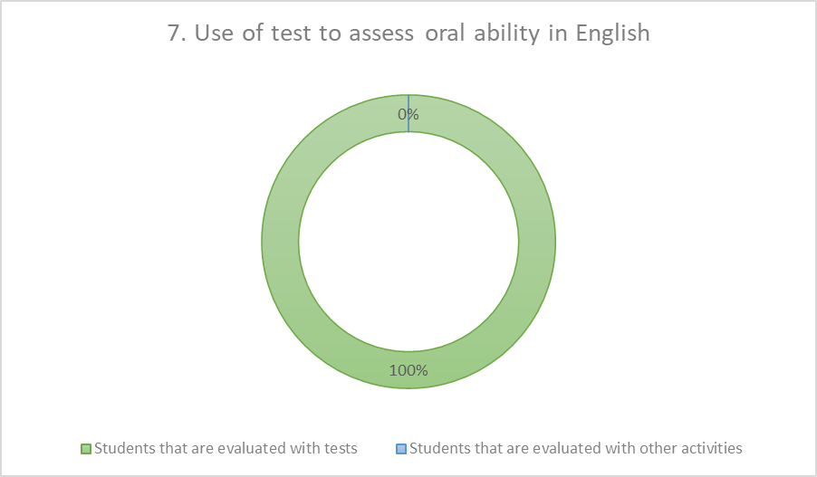
Note: Own elaboration.
Finally, within this category, students were asked if various activities were carried out in their classes to develop oral ability, such as the use of audiovisual resources, language games or conversations, and the answers were not very distant from each other, as can be seen in Figure 8.
Figure 8. Carrying out various activities to develop oral ability

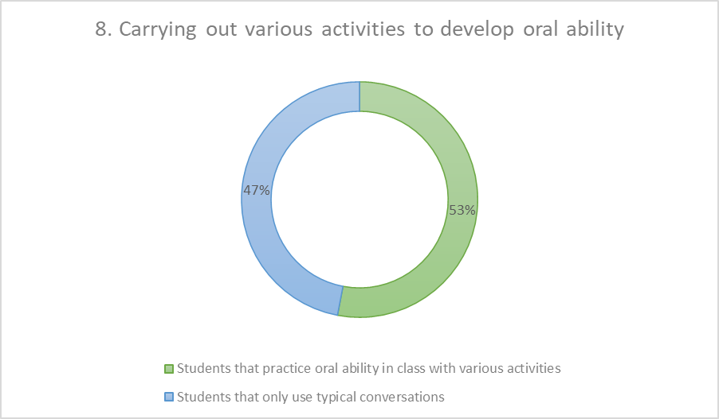
Note: Own elaboration.
Third section: Affective perceptions about oral production in English
In this category, in which it was intended to know the incidence of certain affective factors during oral production in English, the following results were obtained.
In Figure 9 it is possible to know the results about the incidence of nervousness.
Figure 9. Incidence of nervousness when speaking English
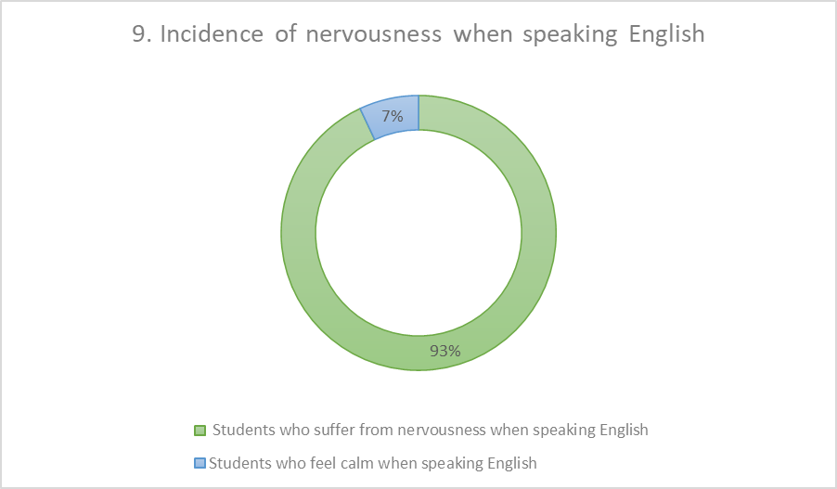
Note: Own elaboration.
Similarly, students were questioned about feeling embarrassed when speaking English. This is shown in Figure 10.
Figure 10. Incidence of embarrassment when speaking English
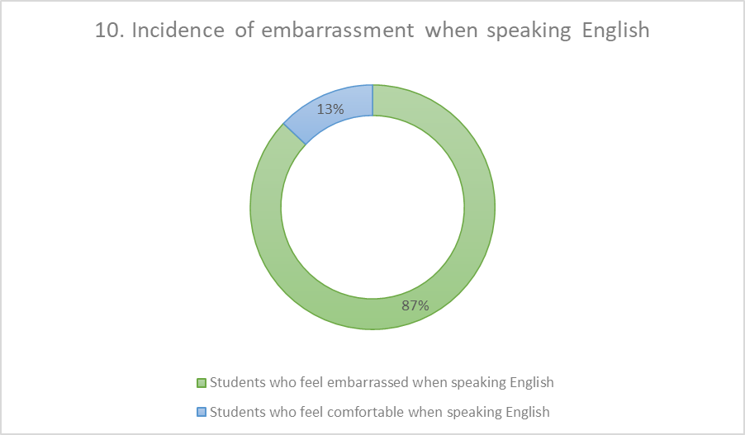
Note: Own elaboration.
In addition, students were asked if anxiety is an affective factor that affects their oral production in English. These results can be seen in Figure 11.

Figure 11. Incidence of anxiety when speaking English
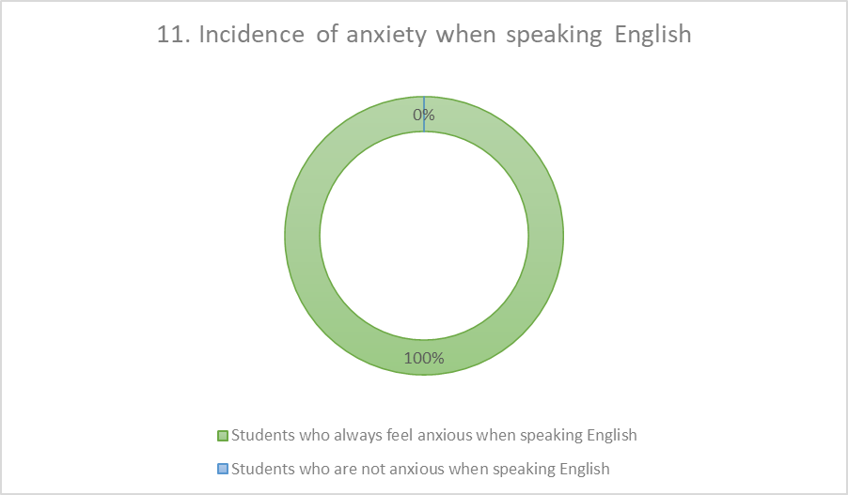
Note: Own elaboration.
In addition to the above, the participants were asked if they feel that their oral ability is inefficient to communicate when they speak English. This can be observed in Figure 12.
Figure 12. Affectation for feeling inefficient when speaking English
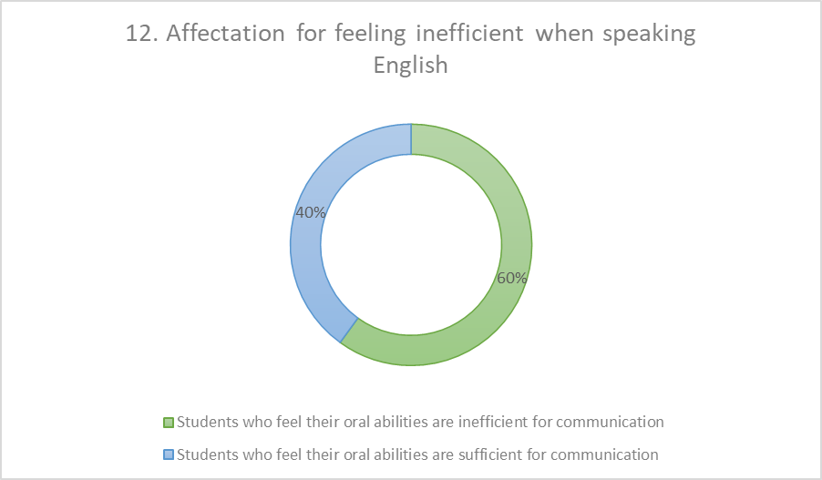
Note: Own elaboration.

Fourth section: Student opinions
In this section, in which the approach was qualitative, and it was sought to learn more about the students' opinions about oral production in English, two main points were contemplated: the factors that they consider affecting oral production the most and the proposals of students to further develop this ability. The results are summarized below.

Factors that mostly affect oral production according to students
Fear of speaking in front of teachers and peers: it was possible to determine that the affective factors greatly affect the oral production of the students, since they mentioned feeling afraid to speak in front of their classmates and teachers. This also coincides with the quantitative results, in which it was possible to appreciate that there is a high incidence of factors such as nervousness, embarrassment and anxiety.
Lack of vocabulary to express themselves adequately on any subject: another aspect that can be highlighted is that the students consider that they do not have enough vocabulary in English to execute their oral production adequately. This aspect may be related to the quantitative results in which it was possible to identify that the participants do not feel comfortable being evaluated with oral exams.
Lack of practice to speak the language: this aspect can be considered of great importance within the results, since the students showed in different responses that they do not use the English language enough in their classes, since they sometimes use the Spanish language and do not always feel motivated to speak English. In addition, many of them mentioned that they do not carry out varied activities to practice their oral abilities.

Proposals to develop oral production according to students
Teaching activities to speak in class: one of the aspects that the students highlighted the most was the lack of activities in their English classes, for which they mentioned that it would be convenient for the teachers to carry out more dynamic exercises that involve speaking in English.
More vocabulary study: likewise, the participants mentioned that it is necessary to study more vocabulary in English to be able to express themselves adequately when they must speak in class or with other people.
More preparation for oral exams and certifications: regarding this point, the students mentioned that they do not always receive sufficient preparation to present oral exams, including those that must be taken in certifications; therefore, they do not feel confident when being evaluated in this way.
Use of audiovisual resources to practice the language: as noted above, the participants mentioned that they do not carry out different activities to practice speaking skills in classes, but what they most suggested is the use of audiovisual resources to practice the language with native content such as movies, songs, among other cultural products.

Discussion
The objective of this article was to identify factors that affect the oral production of language students. The results obtained showed various findings in this regard.
In the first place, it was necessary to analyze the situation of the participants regarding oral ability in English, since it had to be verified that there were difficulties in the abilities of the selected language learners.
This allows the results to be analyzed with respect to the factors investigated, taking into account the perspective of the students about their own circumstances with oral ability.
Thus, when analyzing the factors related to the use and practice of oral production, it was possible to determine that the participants do not usually use the English language all the time they are in English classes, nor do they feel motivated to do so. In addition, almost half of the students do not carry out various activities that allow the oral practice of English, even though all of them mentioned that they are examined with oral tests to evaluate this ability. These results show that the students do not carry out a permanent practice that allows them to improve their skills or become familiar with the oral use of the language in various circumstances. This information was also verified in the qualitative section, since the students pointed out that the lack of varied activities is one of the main problems, since they do not have enough oral practice. In this sense, it must consider what was said by Figueroa & Intriago (2022), who suggested that classes must be dynamic to motivate students to practice English orally. Hence if students say that they are not motivated, it is evident that they do not want to speak the language in class.
However, teachers do evaluate them, which makes them feel scared and unprepared regarding oral production. Of course, this affects during oral exams, possible certifications and even influences the perception they have about speaking. Consequently, as Navarro and Zarate (2016) mentioned, it can be highlighted that the difficulties are related to the activities in the English class. If these activities are not varied, do not motivate students to practice the language, and do not offer sufficient or diverse vocabulary, students may not feel prepared for oral production. In this regard, the participants suggest that the use of audiovisual resources can offer a variety of vocabulary to acquire the English language through natural exposure.
Added to the above, when studying some affective factors, it was possible to identify that these tend to have a great impact on the oral production of the learners. The factor that most affects their speaking is anxiety, followed by nervousness, embarrassment and finally a perception of inefficient when communicating in English. These results coincide with what the learners detailed in the qualitative section, explaining that they tend to feel afraid of speaking in English. In turn, it corroborates the results of Méndez (2016), in which he points out that one of the aspects that most affects the emotions of the learners is the perception that their classmates and the teacher may have of them, which makes them feel insecure, unmotivated to speak English, anxious when participating and with high levels of anxiety.
It should also be noted that the results coincide with the affective filter hypothesis raised by Krashen (1982), since it can be pointed out that affective factors affect students' learning. In this case, negative emotions cause students to participate less in class, therefore they practice oral ability less. In addition, the knowledge they acquire is affected and they do not feel prepared to speak English or to be evaluated.

Conclusion
The students of the Bachelor in Languages ​​consider that the difficulties in the oral production of the English language come from different factors. On the one hand, the circumstances surrounding the teaching they receive influence their development of this ability. Some of these aspects are the activities they carry out in class to practice oral production, the frequency of oral use of the English language and the motivation they receive to be able to continue speaking in English. This means that students do not receive enough instruction or have enough oral practice of the English language during their classes, since they do not have varied activities that motivate them to use the language in which they can acquire diverse vocabulary to be able to express themselves with confidence. In this way, it was possible to determine that most students do not feel satisfied with their level of English in oral ability, since they consider it to be the most difficult and do not feel sufficiently prepared to take oral tests or to achieve certifications in English that require oral evaluation.
On the other hand, regarding the teaching strategies, it is proven that they are necessary for the student to develop oral skills. However, students show that depending on the strategy used could affect positively or negative in their learning, demonstrating that the factors that greatly affect students are affective. These are in turn related to the factors mentioned above, since if it is considered that students do not feel confident when speaking in English, it is logical that they feel nervousness, embarrassment and anxiety when producing the English language, in addition to the fact that this generates a negative perception of themselves, because they do not feel that their oral ability is efficient to communicate.
Therefore, the development process of oral production must occur in environments where the constant practice of the English language is carried out through activities that are varied, interesting and motivating for learners. In addition, these activities should encourage students to feel encouraged, self-confident, without anxiety or fear when speaking in front of others.

Future lines of research
Thanks to the results determined in this research, it is possible to suggest that the development of oral production of the English language requires the implementation of teaching strategies with activities that are planned so that students can function naturally in class and want to practice. Also, these activities must reduce the negative emotions that interfere with learning and especially with practice.
Therefore, one of the lines of research that should be taken up in future studies is the link between certain activities and the emotional behavior of the learners' brains. For example, given that many learners suggest the use of audiovisual resources such as movies, series, songs, among others, it can be determined that these resources cause a positive emotional and cognitive impact on students.
One way to obtain more data in this regard would be the experimental study with language students in which various activities are implemented in which traditional resources such as conversations between classmates and more innovative resources such as role-playing games using some audiovisual products are used. Subsequently, through the application of self-reports, the affective aspects that affect both types of teaching strategies could be analyzed.
Of course, this type of study should be carried out with larger populations, in which various phases can be carried out and the use of multiple resources for oral skill practice can also be accessed. Regarding the teaching strategies, it is proven that they are necessary for the student to develop oral skills. However, students show that depending on the strategy used could affect positively or negative in their learning.

References
Cortés, M. & Iglesias, M. (2004). Generalidades sobre Metodología de la Investigación. Campeche, México: Universidad Autónoma del Carmen. https://www.ucipfg.com/Repositorio/MIA/MIA12/Doc/metodologia_investigacion.pdf
Del Castillo Negrete, Y. E. (september 13th, 2010). La motivación en el estudiante de idiomas en los primeros dos semestres. Congreso Iberoamericano de Educación, Buenos Aires, República Argentina. https://www.adeepra.org.ar/congresos/Congreso%20IBEROAMERICANO/ACCESO/R0862_DelCastillo.pdf
Figueroa-Vidal, R. A., & Intriago-Macías, J. R. (2022). Estrategias para la Producción Oral del Idioma Inglés en la Comunicación de los Estudiantes. Polo del Conocimiento, 7(3). https://polodelconocimiento.com/ojs/index.php/es/article/view/3730
Gonzáles Magallanes, I. A. & Caldera Montes, J. F. (2018). Desarrollo de la producción oral en el idioma inglés mediante la implementación de estrategias cooperativas en el nivel superior. Revista educ@rnos. https://www.researchgate.net/publication/331596028_Desarrollo_de_la_produccion_oral_en_el_idioma_ingles_mediante_la_implementacion_de_estrategias_cooperativas_en_el_nivel_superior
Kalan, M. (2007). Las dificultades lingüísticas y afectivas de la expresión oral en clase y en la vida real. Las destrezas orales en la enseñanza del español L2-LE, (2), 981-996. https://cvc.cervantes.es/ensenanza/biblioteca_ele/asele/pdf/17/17_0981.pdf
Krashen, S. (1982). Principles and Practice in Second Language Acquisition. Prentice-Hall.
Méndez López, M. (2016). Las emociones en el aprendizaje de una lengua extranjera: su impacto en la motivación. Revista Internacional De Lenguas Extranjeras / International Journal of Foreign Languages, (5), 27-46. https://doi.org/10.17345/rile5.1002
Navarro dos Santos, H. D. C., & Zarate Rodríguez, W. E. (2016). Dificultades que presentan los estudiantes en la producción oral del inglés en el grado quinto de primaria del Liceo Max Planck. (Degree thesis, Universidad de la Salle). https://ciencia.lasalle.edu.co/lic_lenguas/169
Olivarez Oropeza, G. (2017). El uso de estrategias para desarrollar la expresión oral en inglés en estudiantes de segundo semestre de bachillerato del CECyTE Tecamachalco (Master’s thesis, Universidad Iberoamericana de Puebla). http://hdl.handle.net/20.500.11777/3343
Sagastegui Toribio, E. E., Vilca Aguilar, L. M., & González Castañeda, A. C. (2018). Estrategias de enseñanza-aprendizaje para mejorar la producción oral en inglés de los estudiantes de la Escuela de Idiomas de la UCV2017. UCV-Scientia, 10(1), 75-81. http://revistas.ucv.edu.pe/index.php/UCV-SCIENTIA/article/view/1770

Rol de Contribución | Autor (es)
Conceptualización | Pedro Antonio Morales Uriostegui (Principal) Eleazar Morales Vázquez (apoya)
Metodología | Pedro Antonio Morales Uriostegui (Principal) Eleazar Morales Vázquez (apoya)
Software | No aplica
Validación | Pedro Antonio Morales Uriostegu, Eleazar Morales Vázquez (igual)
Análisis Formal | Pedro Antonio Morales Uriostegui (Principal) Eleazar Morales Vázquez (apoya)
Investigación | Pedro Antonio Morales Uriostegui (Principal) Eleazar Morales Vázquez (apoya)
Recursos | Pedro Antonio Morales Uriostegui (Principal) Eleazar Morales Vázquez (apoya)
Curación de datos | Pedro Antonio Morales Uriostegui (Principal) Eleazar Morales Vázquez (apoya)
Escritura - Preparación del borrador original | Pedro Antonio Morales Uriostegu, Eleazar Morales Vázquez (igual)
Escritura - Revisión y edición | Pedro Antonio Morales Uriostegu, Eleazar Morales Vázquez (igual)
Visualización | Pedro Antonio Morales Uriostegu, Eleazar Morales Vázquez (igual)
Supervisión | Pedro Antonio Morales Uriostegu, Eleazar Morales Vázquez (igual)
Administración de Proyectos | Pedro Antonio Morales Uriostegu, Eleazar Morales Vázquez (igual)
Adquisición de fondos | No aplica

